**Trends on the evolution of education for 4- to 5-year-old children in Zimbabwe**

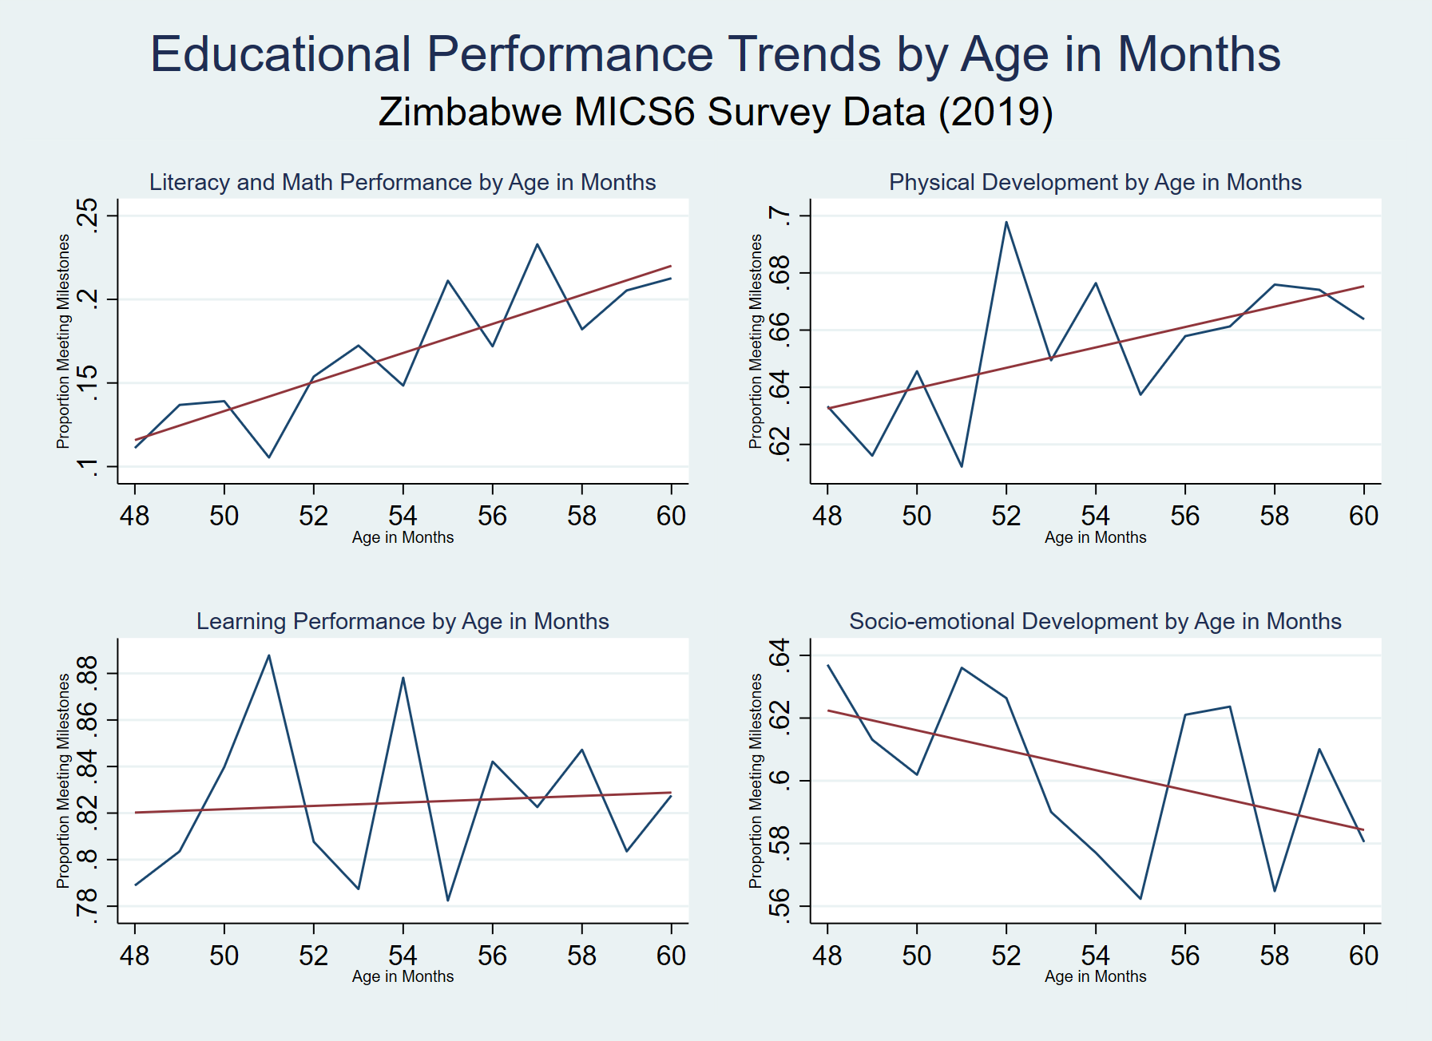**The**